MODULE-6

PART A: MAGNETIC HYSTERESIS OF NICKEL

Aim:

To study the manetization behaviour with alternating magnetic field and report (i)hysteresis curve (ii) Hc (iii) Bs(iv)Br

Theory:

Magnetic Materials

All magnetic materials exhibit spontaneous magnetic moment - a magnetic

moment even in zero magnetic field. They have ordered arrays of magnetic moments, i.e. electron spins and spin magnetic moments are arranged in a regular manner, as illustrated in Fig. 6.1. Magnetic materials can be classified into ferromagnetic [spins aligned in the

same direction or parallel, equal moments of one type only, e.g. Fe, Co, Ni, Gd],

antiferromagnetic | [spins |  | on neighboring atoms in opposite |  | directions or antiparallel, all
moments of one type |  | only and equal, |  | net saturation magnetic moment nil, e.g. Cr], and
ferrimagnetic [spins on neighboring atoms in opposite directions or antiparallel, but more
than one type of moment present |  |  |  | with unequal moments, |  | e.g. NiO.Fe203, | occurs in
compounds only], See.Fig. 6.1
Ferromagnetic Domains
In a ferromagnetic specimen, often, the net magnetic moment |  |  |  |  |  | is much less than
what one would expect from the sum of |  |  |  | magnetic moments of all the individual atoms,
and application of an external magnetic field is required to obtain the saturation magnetic
moment. This phenomenon is explained by the presence of magnetic domains. A domain
is a small region in a magnetic |  |  |  | material, within which the local magnetization is
saturated, i.e. spins on all the atoms are parallel. |  |  |  |  | 0 .
However, the directions of magnetization of different domains do not coincide, as
illustrated in Fig. 6.2, resulting in a small resultant magnetic moment. Magnetic domains
are responsible | for | the | hysteresis loop. Fig.6.3 represents the |  |  | magnetization curve, i.e.
magnetization M as a function of |  |  |  | the external magnetic field H, of a ferromagnetic
materia1. It is assumed that the net magnetization was zero for the specimen, before the
application of the external magnetic field. The increase in |  |  |  |  |  | the magnet moment of the
specimen under the action of an applied |  |  |  | magnetic field takes | place by two independent

Lab Manual/ESO214 /MME/IITK

processes: [i] in weak applied fields, the volume of domains which are favorably oriented with respect to the field increases at the expense of unfavorably oriented domains, See Fig. 6.3 [ii] in strong applied fields, the magnetization rotates toward the direction of the

field. These two processes can explain why a loop is traced in the B-H plane, as the magnetic field completes a cycle. Technical terms defined by the hysteresis loop are shown in Fig.6 3.

The domain structure of ferromagnetic materials affects their practical properties. In a transformer core, we want a high permeability = B/H. In a permanent magnet, we want a high coercive force. By suppressing the possibility of boundary displacement, we may achieve a high coercivity, the suppression may be accomplished by using very fine particles or by precipitating a second metallurgical phase, so that the specimen is heterogeneous on a very fine scale. By making the material pure homogeneous and well oriented we facilitate domain boundary displacement, and thereby attain high permeability.

The area of the hysteresis loop represents an energy loss. In industrial applications, magnetic materials are classified on the basis of the loop area and characteristics. Soft magnetic materials have low hysteresis and eddy current losses, and

high magnetic permeability. [Eddy currents flow in a magnetic material due to the induced emf. This current has a corresponding I 2 R loss.] These materials [e.g. 97Fe3Si,

Fe₂ O₃ , NiO.Fe₂ O₃ ] industrially are most important.

Hard magnetic materials [e.g. Alnico 5: 51Fe14Ni24Co8A13Cu], on the other hand, have high coercivity, and large remanent and saturation magnetizations.

Hence, to characterize any magnetic material, it is necessary to obtain its hysteresis loop.

Measurement Setup:

The hysteresis loop measurement setup has three components: [i] the solenoid-specimen-pickup coil combination; [ii] the loop tracer control cabinet; and [iii] the oscilloscope for loop tracing.

The magnetic specimen is a Ni wire, 1.13 mm in diameter, 44 mm in length. To obtain its hysteresis loop, the ac hysteresis loop tracer will be used. The magnetic field is provided by a solenoid, into which the magnetic specimen is placed. A pick-up coil is used to monitor the magnetization of the specimen. The specimen, the pick-up coil, and

Lab Manual/ESO214 /MME/IITK

the solenoid are, coaxial. The pick-up coil is shorter than the specimen in length, is

located in the center of the specimen, and closely encircles the specimen.

The hysteresis loop tracer feeds to the x-axis of an oscilloscope a signal proportional to the magnetic field H, and to the y-axis a signal proportional to the magnetization M. Hence, as the applied magnetic field is sinusoidal, a loop is traced on

the oscilloscope, | for | a given magnitude of the | applied sinusoidal magnetic field. This
loop will not only increase in size with the magnitude of the sinusoidal field, but will also
change in shape. | For | low to medium magnitudes, the loop shape will be rectangular to
parallelogram. At high magnitudes, it will approach the form of Fig. 6.3, and will indicate
saturation of magnetization.
Several problems are encountered in practice while measuring the hysteresis loop.
The magnetic field becomes non-uniform on account of: [i] open specimen; and [ii] fields
induced by the eddy |  | current. The eddy currents | also cause the forward and backward

paths traced near saturation magnetization to be different, thereby leading to a small loop inside the large loop in the saturation region.
Experimental Procedure:

- Inspect the measurement setup, in particular the solenoid-specimen-pickup-coil combination and the loop tracer control panel.

- Calibration of the oscilloscope and settings of the area ratio and demagnetization factor.
- Record: [i] loop shape; [ii] loop width [in mm]; [iii] tip to tip height [in mV]; and

[iv] y-axis intercept, [in mV] for magnetic fields of 50, 100, 150, 200, 250, and

300 Gauss.

- The loop shape is to be recorded as free-hand sketches on the result sheet. The values of field, loop width, tip to tip height, and y-axis intercept are to be put in a tabular form.

- From the table, estimate the saturation magnetization _{S} inM mV [= half the

asymptotic value of the tip to tip height], the remanent magnetization M r in mV [=

the asymptotic value of the y-axis intercept]. To estimate the coereivinty H
C

mm, plot on a small-size graph paper the loop width versus the field. Take H C as

half the value of the intercept of the linear part of the plot for zero field.

Lab Manual/ESO214 /MME/IITK

6. Calculate H_{C} in Oersted, M _{r} in Gauss, M_{S} in Gauss, using the following relations:

1 mm = 8.58 Oe 1mV= 2.63 G

Simple ferromagnet simple antiferromagnet Ferrimagnet

Can ted antiferromagnet Helical spin array Ferromagnetic energyband

Fig 6.1 Possible ordered arrangements of electro n spins.
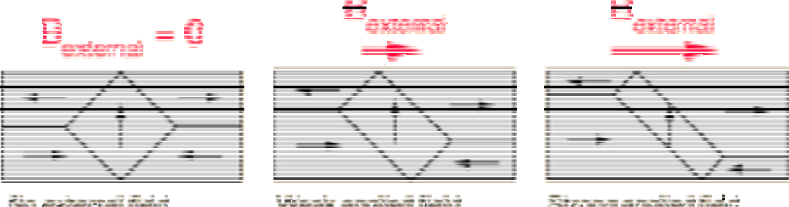

Fig 6.2 Magnetic d omains behavior with applied field

These illustrations of domains are conceptual only and not meant to give an accurate scale of the size or shape of domains. The microscopic evidence about magnetization indicates that the net magnetization of
ferromagnetic materials in response to an external magnetic field may actually occur more by the growth of the domains parallel to the applied field at the expense of other domains rather than the reorientation of the domains themselves as implied in the sketch

Lab Manual/ESO214 /MME/IITK
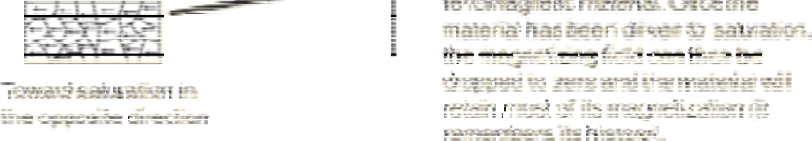

Fig 6.3a Magnetisation Curve
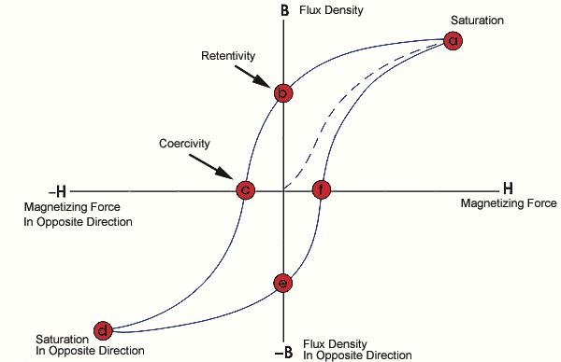

Fig 6.3b Magnetisation Curve

Lab Manual/ESO214 /MME/IITK
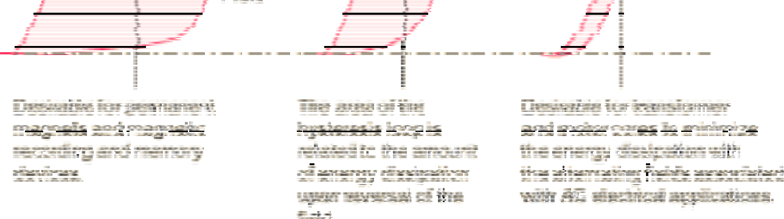

Fig 6.3c Magnetisation Curve
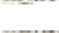

Questions:

- Why there is an extra secondary loop appears top and bottom of the hystersis loop along with the original loop?

  - Explain the difference in B-H Loop of hard and soft iron samples?

Module-6
Electric Characterization of Semiconductor
(PART B1)
Aim:
Room temperature measurement of resistivity, carrier concentration and carrier mobility for a semiconductor having a majority carrier, either n- or p- type (using Hall measurement set-up)
Theory:
1.1 Electronic structure of materials
Solids are classified into three main groups namely metals, insulators, and semiconductors, on the basis of their energy bands. Energy bands of any solid are obtained from solution of Schrödinger's equation for that solid, and represent the electron Eigen energies as a function of the electron wave vector [i.e. momentum]. The results of a hypothetical quantum-mechanical calculation of electron energy as a function of the lattice spacing for silicon as shown in Fig. 10.1. This schematic is very instructive for qualitative understanding of the occurrence of energy bands and forbidden energy gaps. A solid can be approximated to an ideal gas wherein each isolated atom has its discrete electron energy levels [two levels are shown on the far right of the diagram]. These Eigen energies expand into energy bands, as we decrease the inter-atomic spacing to form a solid. As the inter-atomic spacing is reduced, the interaction between atoms takes place and keeps increasing. Finally, in a solid, atoms very strongly interact with each other, and the valence (the outermost) electrons cannot claim to belong to any particular atom. What this means is that if the solid has N atoms, each atomic level must split (to remove degeneracy) into N sub-levels, very closely spaced to each other [as N is a very large number] to accommodate electron levels of N atoms. This is how an energy band of very closely spaced sub-levels evolves. The energy gap between the allowed energy bands is the forbidden energy gap or band gap E_{g.} In the quantum mechanical picture, electrons cannot have any energy in the forbidden energy range. The highest completely filled [i.e. occupied with electrons] energy band at 0K is called valence band, and the next higher band is called the conduction band. Fig.10.2 illustrates the basic differences between the 3 classes of solids in terms of the valence and conduction bands. In Fig.l0.2, the abscissa is some x-direction in the solid, while the ordinate is the electron energy. As Fig.10.2(c) indicates, the metals ae characterized by overlapping conduction and valence bands or partially filled conduction bands. The shaded area represents energy levels occupied by electrons. The non-metals, i.e. semiconductors and insulators, are characterized by completely empty conduction bands at 0K. Semiconductors have smaller band gap than insulators, as indicated in Figs. 10.2(a) and 10.2(b).

Fig 10.1 The splitting of 3s and 3p energy levels in silicon to form allowed and forbidden bands

Fig 10.2 Schematic energy band representation of (a) Insulator, (b) Semiconductor and (c) Metal
In order to choose a material suitable for a particular device we need to know its electrical properties. In this experiment we will measure resistivity, carrier concentration, carrier mobility, and band-gap of the semiconductor
1.2. Carrier concentration and mobility measurement
The resistivity measurements of semiconductors cannot reveal whether one or two types of carriers are present; nor distinguish between them. However, this information can be obtained from Hall Coefficient measurements, discovered in 1879 by J. Edwin Hall.
1.2.1 Hall Effect Measurement:
Since current in a semiconductor consists of the movement of electrons or holes, or both, moving charges will respond to magnetic field that is not parallel to their motion due to Lorentz force. Now consider a bar semiconductor, having dimensions x, y, and z. Let J is directed along x and H along z then $E_{H}$ will be along y, as shown in Fig 10.3. When there is no electric field, the charges follow an approximately straight line. However, when a perpendicular magnetic field is applied, electron and holes will be separated by opposite forces. They will in turn produce an electric field ($E_{H}$) which depends on the cross product of magnetic field, Hand the current density, J.

${ E}_{H}=R_{H}.J × H$ (eq. 10.1)
Where $R_{H}$ is called Hall coefficient.
Fig. 10.3 Schematic of Hall coefficient measurement

Then we can write-
$R_{H}=\frac{(V_{H}.Z)}{IH}$ (eq. 10.2)
Where, $V_{H}$ is the Hall voltage appearing between the two surfaces perpendicular to ‘y’ and .

$I=J.y.Z$ (eq. 10.3)

In general, the Hall voltage is not a linear function of magnetic field applied; i.e the Hall coefficient is not generally a constant, but a function of the applied magnetic field. However, it is easy to calculate Hall voltage if it is assumed that all carriers have the same drift velocity. We will do this in two steps.

(a) By assuming that carriers of only one type present
Metals and doped semiconductor are the examples of this type where one carrier dominates. The magnetic force on the carriers is $F_{m}=e(v×H)$ and is compensated by the Hall field $F_{H}=eE_{H}$, where $v$is the drift velocity of the carriers. Assuming the direction of various vectors as before
$v×H=E_{H}$, (eq. 10.4)
From simple reasoning, the current density J is the charge q multiplied by the number of carriers traversing unit area in unit time, which is equivalent to the carrier density multiplied by drift velocity i.e. J = q n v

By putting these values in equation (10.3)
$R_{H}=\frac{E_{H}}{IH}=\frac{vH}{nqvH}=\frac{1}{nq}$ (eq. 10.5)
From this equation it is clear that the sign of hall coefficient depends upon the sign of the q. This means, in a p-type specimen the $R_{H}$ would be positive, while in n-type it would be negative. Also for a fixed magnetic field and input current, the hall voltage is proportional to $1/n$ or its resistivity. When one carrier dominates, the conductivity of the material is
$σ=n q μ$ (eq. 10.6)

Where $μ$ is the mobility of the charge carriers.
Thus $μ=R_{H}σ$ (eq. 10.7)
$R_{H}$ is expressed in cm³ coulomb⁻¹ and $μ$ is expressed in units of cm² volt ⁻¹sec⁻¹
(b) By assuming that of both types carriers present.
Intrinsic and lightly doped semiconductors are the examples of this type. In such cases the quantitative interpretation of Hall coefficient is more difficult since both types of carriers contribute to Hall field. It is also clear that for the same electric field, the Hall voltage of p-carriers will be opposite sign from the n- carriers. As a result, both mobilities enter into any calculation of Hall coefficient and a weighted average is result i.e
${ R}_{H}=\frac{μ_{h}^{2}p-μ_{n}^{2}n }{{2\left(μ_{h}p+μ_{n}\right)}^{2}}$ (eq. 10.8)
Where $μ_{h}$ and $μ_{n}$ the mobilties of holes and electrons, p and n are the carrier densities of holes and electrons. Eq. 10.7 correctly reduces to Eq. 10.4 when only one type of carrier is present.
Since the mobilties $μ_{h}$ and $μ_{n}$ are not constants but function of temperature (T) the Hall coefficient given by Eq. 10.4 is also a function of T and it may become zero, even change sign. In general, $μ_{n}$ > $μ_{h}$ so that inversion may happen only if p > n, thus Hall coefficient inversion is characteristics only of p-type semiconductors.
1.3 Design of Experiment:
- Resistivity, carrier type, carrier concentration and mobility
- What parameters you need to measure resistivity, carrier type, carrier concentration and mobility?
- What are the possible assumptions in each measurement?
- Can you validate your assumptions via experimental data? What additional data you need to take in order to validate your assumptions?
(Answers are hidden in the text of the theory. Do read it carefully)

1.4 Analysis:
- What graphs do you need to plot?
- In Hall measurement experiment: report resistivity, carrier type and concentration, and mobility
- Compare room temperature resistivity of the two samples and comment.
1.5 Questions:
- What is Hall Effect?
- What is the effect of temperature on Hall coefficient of a lightly doped semiconductor?
- Why resistances of the sample increase with increase of magnetic field?

1.6 Procedure:
(a) For measuring resistivity of Ge (Van der Pauw Method)
The Van der Pauw method is commonly used to measure the resistivity of a sample of any arbitrary shape.
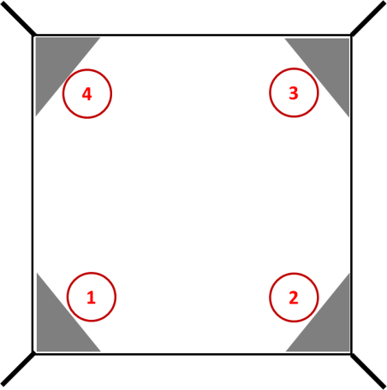
Fig.10.4 Electrical Configuration
1. To measure the resistance, current is caused to flow along one edge of the sample (I₁₂) and the voltage is measured across the opposite edge (V₃₄).
The resistance can be calculated from Ohm’s law
$$R_{12, 34}= \frac{V_{34}}{I_{12}}$$
Similarly measure $R_{ 34, 12}$, $R_{21, 43}$, $R_{43,21}$ and find out the average for vertical configuration
$$R_{Vertical}= \frac{R_{12, 34}+R_{34, 12}+R_{21, 43}+R_{43,21}}{4}$$

2. Measure the resistance for horizontal configuration as given below
$$R_{Horizontal}= \frac{R_{23, 41}+R_{41, 23}+R_{32, 14}+R_{14, 32}}{4}$$
3. Find out the ratio between $R_{Vertical}$ and $R_{Horizontal}$ such a way that the ratio to be greater than 1
$$\frac{R_{Vertical}}{R_{Horizontal}} or \frac{R_{Horizontal}}{R_{Vertical}} ≥1$$
4. Find out the correction factor (f) for the corresponding ratio from the plot given in Appendix (Fig. 10.5)
5. Using the following relation, find out the resistivity of the sample
$ρ= \frac{π}{\ln{(2)}} t\left(\frac{R_{Vertical}+R_{Horizontal}}{2}\right)f$(eq. 10.9)
Where, t- thickness of the sample, f correction factor for the corresponding ratio
(b) For measuring Hall coefficient
- Calibrate the Gaussmeter by adjusting the current in the constant current supply unit and note down the value of magnetic field corresponding to it.
- Connect the widthwise contacts of the Hall Probe to the terminals marked Voltage and lengthwise contacts to terminals marked Current.
- Switch ON the Hall Effect set up and set the current to an appropriate value (say 5 rnA).
- Switch over the display to voltage side. There may be some voltage reading even outside the magnetic field. This is due to imperfect alignment of the four contacts of the Hall Probe and is generally known as the Zero field potential. In all cases this error should be subtracted from the Hall voltage reading.
- Now place the probe in the magnetic field and switch on the electromagnet power supply and adjust the current to any value. Rotate the Hall probe till it become perpendicular to magnetic field. Hall voltage will be maximum in this adjustment.
- Now keeping the current constant, measure Hall voltage as a function of magnetic field.
- Keeping the magnetic field constant, vary the current and measure the hall voltage.
1.7 Precautions:
- For Hall Effect set up, probe should be in middle of electromagnet before taking readings.
- Before taking reading, zero adjustment is to be done

Appendix 1
Van der Pauw correction factor for resistivity measurements
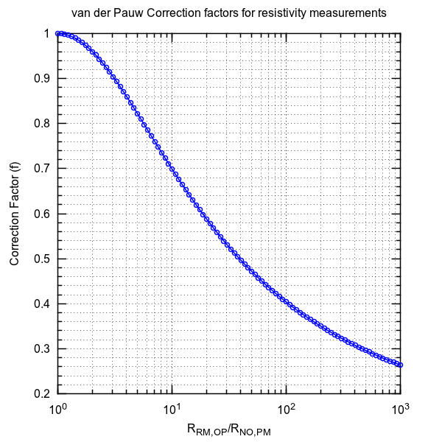
Fig. 10. 5 Van der Pauw correction factor plot

Appendix 2
Hall measurement set-up

Fig. 10.6 Experimental set up of Hall coefficient measurement
The Hall effect measurement set up is shown below with labeled important parts. The specifications of the instrument are:
1. Hall probe:
- Contacts: Spring type (solid silver)
- Hall voltage: 0.1-1 volt
- Thickness of Ge crystal: 0.4
- Resistivity: 10 Ω cm
2. Digital milli-voltmeter:
- Range: 0-200 mV
- Resolution: 100 µV
- Accuracy: 0.1% of reading 1digit
3. Constant current power Supply:
- Current range: 0-4 A
- Resolution: 10 µA
- Load Regulation: 0.1%
- Line Regulation: 0.1%
4. Electromagnet, EMU-50V:
- Field intensity: 7.5 Gauss at l0 mm Gap
- Pole pieces: 50 diameters
- Yoke material: U shaped soft iron
- Power Requirement: 0-30V@4.0A

Module-6
Electric Characterization of Semiconductors
(PART B2)
Aim:
Temperature dependent measurements of resistivity to evaluate band gap energy (E_{g}) in germanium (G_{e}) semiconductor (using Four-point probe set-up with furnace)
Theory
2.1 Electrical Properties of Materials
2.1.1 Resistivity Measurement:
When an electron or a hole (i.e. a missing electron) responds to an applied electric field it accelerates, and gain kinetic energy (A force acts on a charge carrier in an electric field). This means that it is excited to a higher energy state. So, only those electrons and holes can respond to an applied electric field that has empty higher states available for excitations. (Note that Pauli's exclusion principle requires that no two electrons can have the same eigen energy, that too, only if they have opposite spin). In a moderate electric field, gain in the kinetic energy is a very small fraction of the band gap energy. For this reason, the valence electrons in a non-metal at 0 K cannot respond to an applied electric, as they see no higher states to which they can be excited. For this reason, a non-metal is a perfect insulator at 0 K as it has no conduction electrons or free carriers.
At room temperature (i.e. 300K), thermal vibrations break a minute fraction of the covalent bonds in a semiconductor. In other words, the thermal energy kT excites a very small fraction of valence electrons in a semiconductor over the band gap E_{g} into the conduction band. This fraction naturally depends upon the values of E_{g} and kT. This is known as thermal generation of free carriers. So thermal generation always gives rise to electron-hole pairs, i.e. equal numbers of conduction electrons and holes are created. The number of such pairs per unit volume is known as the intrinsic carrier density ni which is given by:
n_{i} = C (- $\frac{E_{g}}{2kT})$ (eq. 10.10)
C is a constant and has same unit as n_{i}. i.e. cm⁻³ k is Boltzmann's constant, and T is absolute temperature. From equation (10.8), it follows that for a semiconductor at 300K, the conduction band is slightly filled with electrons, and the valance band is slightly empty for electrons, or slightly filled with holes. A conduction electron is a free carrier because it has empty higher states to which it can be excited to by gain in kinetic energy. A hole [which is always in the valence band] is also a free carrier, as it can be excited to all states filled by electrons. Note that in the energy band diagram, going up increases the electron potential energy, -qV, but decreases the hole potential energy, qV, where V is the electrostatic potential. When a conduction electron has no kinetic energy, then it is at the conduction band lower edge E_{c}. Similarly, when a hole has no kinetic energy, then it is at the valence band upper edge E_{v}. The free carrier density in the pure semiconductor is n_{i}. The conductivity of an intrinsic (pure) semiconductor is therefore proportional to n_{i}, while the resistivity, ρ, will be inversely proportional to it.
,
σ = n_{i} q (µ_{n}+ µ_{p}) (eq. 10.11)

Where q, µ_{n} and µ_{p} are electron charge, electron and hole mobility, respectively.
2.1.2 Four Point Probe Resistivity Measurement:
The resistivity of a solid is obtained experimentally by passing a current through the solid, and measuring the current through and the voltage drop across the solid. This measurement is easier for metal. But for non-metal, the contact between metal current lead and non-metal sample act as high resistance junction. A metal semiconductor contact is a Schottky barrier diode. This a complication, because if the voltage is measured between the two current leads, then this will not only include the voltage drop across the semiconductor, but also the large voltage drop across the two metal semiconductor contacts. For this reason the semiconductor resistivity measurements involves four equidistant probes, as shown in Fig 10.7. The two outer probes carry the current from a constant current generator, while the two inner probes are used for voltage measurement by a very high input resistance, then, there is no current flowing through the voltmeter. Ideally, the voltmeter should have infinite resistance then there is no current flowing through the voltmeter, hence there will be no voltage drop across the metal-semiconductor contacts at the voltage probes. This will ensure correct measurement of the voltage drop in the semiconductor in the region between the two inner probes. Note the current enters/leaves the semiconductor at the probes flowing vertically, while in the central region the two outer probes, it flows horizontally. Also, the current flux density is not uniform. These complications result in the following relation between the resistivity p, the probes spacing d, the current I, and the voltage V between the two inner probes.
ρ=2π (dV/I) (correction factor) (eq. 10.12)
Correction factor is based on the sample configuration and dimensions. For details see Appendix 3.

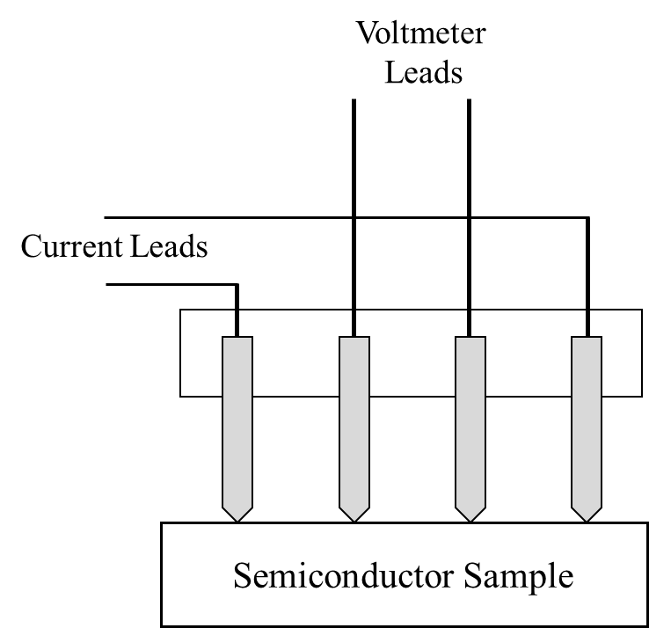

Fig. 10.7 Four Point Probe Setup

2.1.3 Temperature dependent measurement (band gap measurement)
The resistivity, ρ, is given by-
ρ = C ( $\frac{E_{g}}{2kT})$ (eq. 10.13)

Where, C is a constant. A plot of ln(ρ) versus 1/T will therefore be a straight line, whose slope will be E_{g}/2k. Hence the band gap of a semiconductor can be determined from measurement of resistivity ρ as a function of temperature T.
The semiconductor sample is in the form of wafer. The four-probe set is spring loaded, with collinear and equally spaced probes, and Zn- coated probe tips. The set is mounted on a stand, current and voltage leads are provided (see Fig 10.8). The probe set and the sample stage are arranged in a small box-type oven. The oven temperature can be varied from 300 to 475 K.

2.2 Design of experiment:
- Measure the resistivity at room temperature.
- What should be the heating rate of oven? Keep in mind you need to have enough time at a given temperature to take a reading.
- What should be the range of temperature for this experiment?
- What should be the interval at which you need to take the reading?
2.3 Analysis:
- What graphs do you need to plot?
- In Four-point probe measurement: report room temperature resistivity and band gap
2.4 Questions:
- What are n-type and p-type semiconductors?
- Does the hole actually move?
- What is advantage of four probe method over the conventional methods?

Experimental Four probe set up:

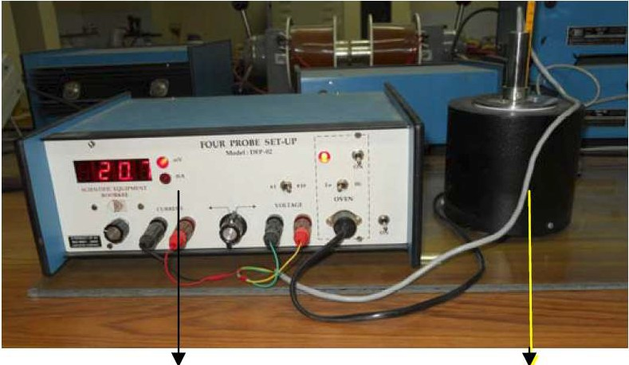
milli-ammeter cum milli-voltmeter Oven
Fig. 10.8 Experimental set of four probe method
A four probe set up is shown above with following specifications:
- Oven: Temperatures can go up to 200°C
- Current: 0-200 mA
- Voltage: 0-200 mV
2.5 Procedure:
- Fix the current to say 5.0 mA.
- Increase the temperature and measure the corresponding values of voltage at appropriate intervals.
- The band gap energy can be calculated using the standard relation.
2.6 Precautions:
- For band gap measurement, current is fixed at 5.0 mA , so do not change it.
- Do not take specimen out from the furnace, when it is hot.

Appendix 3
Correction factor for Four-point-probe measurement
For arbitrary shaped samples of finite geometry, the resistivity is given by
ρ = 2π d F (V/I) (eq. 10.14)
Where, F is the correction factor which corrects for probe location near sample edges, for sample thickness, sample diameter, probe placement, and sample temperature. It is usually a product of several independent correction factors. For samples thicker than the probe spacing, the simple, independent correction factors contained in F of above eqn. are no longer adequate due to interactions between thickness and edge effects. Fortunately, the samples are generally thinner than the probe spacings, and the correction factors can be independently calculated. For collinear or in-line probes with equal probe spacing, d, we write F as a product of three separate correction factors-
F = F₁F₂F₃

Each of these factors can be further subdivided. F₁ corrects for sample thickness, F₂ for lateral sample dimensions, and F₃ for placement of the probes relative to the sample edges. Most four-point probe measurements are made with insulating bottom boundaries.
For very thin samples, i.e. t ≤ d/2, F₁=(t/d)/21n2, where t is sample thickness and F₂ and F₃ are approximately equal to unity. Therefore eqn (1) becomes

ρ =4.532 t $\frac{V}{I}$ (eq. 10.15)

Where, t is in cm, V is in volts and I is in amperes. (The value of ρ would be in ohm.cm)

